  - Workspace-level access

Key points
- You can share a workspace with a user or Entra ID security group (or M365 group). This will give access to everything in the workspace.

- When you share, you give the person/ group a role in the workspace. One of:
  - Admin
  - Member
  - Contributor
  - Viewer

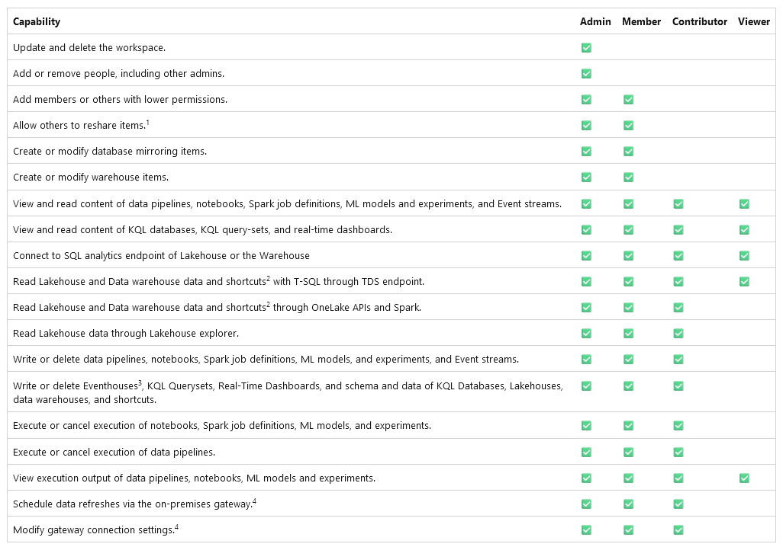
- Capabilities of each workspace-level role:

- The creator of a workspace gets Admin role.
- When the same person has multiple role assignments (normally because they are members of multiple security groups), the highest role is prioritized.

